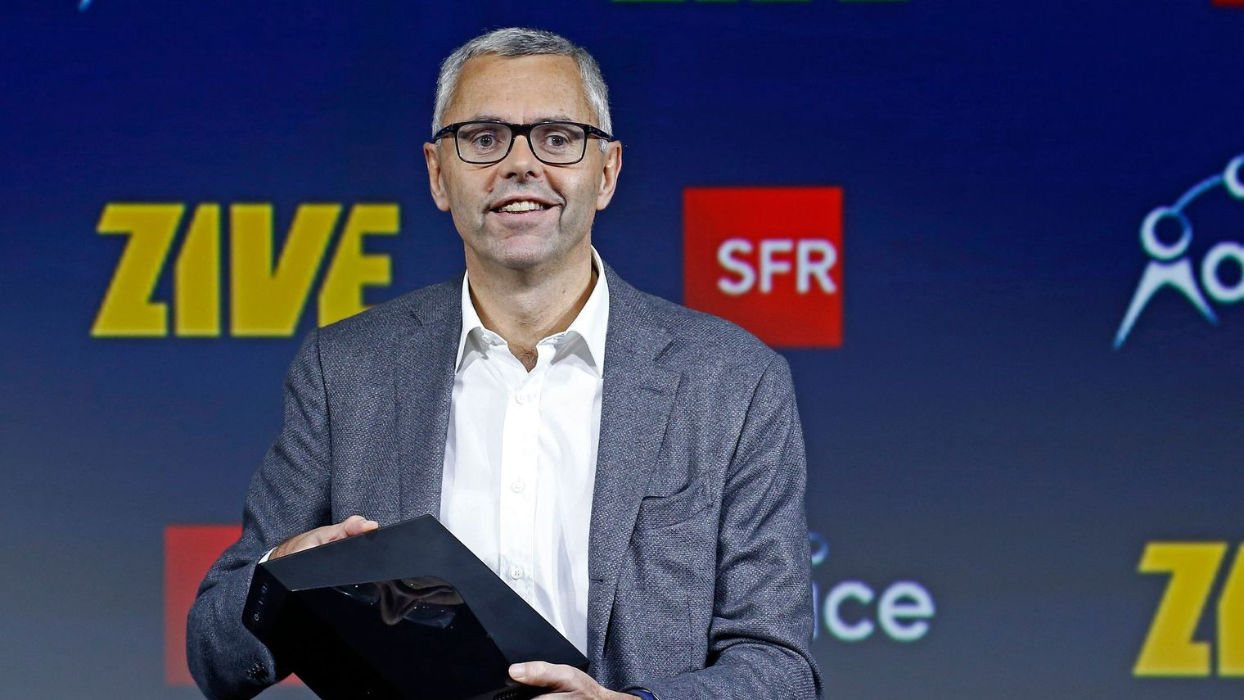

**Name:** Jabhi Rish

**Age:** 67

**Gender:** M

**Location:** USA

**Company:** DL Traders

**Position:** CEO

**Education Level:** MBA

**Background:** Compute Science Engineering, Masters in Information Management and MBA in Finance. He has been running his company for 13 years and plans to open offshore offices.

**Bio:** Excelling engineer working into the industry as a developer, pursued masters towards a techno management industrial role. Finally, accomplishing and MBA and acquiring a position of CEO at DL traders

**Goal:** Improve the financial progress and optimization of the organization, increase the turnover through the methods deployed, eradicating the points of loss and loopholes through the business process and operations, and overall progress of DL traders and the world as a whole.

**Needs:** Financial outstanding, budgeting for the next fiscal year, increase in overall company productivity, reducing costs, mitigating risks, understanding requirements and choosing assets and logistics appropriately.

**Pain Points:** Low performance and productivity, expensive production cost, low margin for profit, in exhaustive taxation planning.

**Biases:** cheaper fork force/ more productivity